SCHOOLOFCOMPUTER SCIENCE AND ARTIFICIAL INTELLIGENCE |  |  |  |  | DEPARTMENTOFCOMPUTER SCIENCE ENGINEERING
Program Name: M. Tech/MCA/MSC |  |  |  | Assignment Type: Lab |  |  | AcademicYear:2025-2026
Course Coordinator Name |  |  |  | Venkataramana Veeramsetty
Course Code |  |  | 24CS002PC215 | Course Title |  | AI Assisted Problem Solving Using Python
Year/Sem |  |  | II/I | Regulation |  | R24
Date and Day  of Assignment |  |  | Week5- Tuesday | Time(s)
Duration |  |  | 2 Hours | Applicable to  Batches
AssignmentNumber:13.3(Presentassignmentnumber)/24(Totalnumberofassignments)
 | Q.No. | Question |  |  |  |  |  | ExpectedTime  to complete
 | 1 | Lab 13 – Code Refactoring: Improving Legacy Code with AI Suggestions  Lab Objectives  - To introduce the concept of code refactoring and why it matters (readability, maintainability, performance).  - To practice using AI tools for identifying and suggesting improvements in legacy code.  - To evaluate the before vs. after versions for clarity, performance, and correctness.  - To reinforce responsible AI-assisted coding practices (avoiding over-reliance, validating outputs).  Learning Outcomes  After completing this lab, students will be able to:  - Use AI to analyze and refactor poorly written Python code.  - Improve code readability, efficiency, and error handling.  - Document AI-suggested improvements through comments and explanations.  - Apply refactoring strategies without changing functionality.  - Critically reflect on AI’s refactoring suggestions.  Task Description #1 – Remove Repetition  Task: Provide AI with the following redundant code and ask it to refactor  Python Code  def calculate_area(shape, x, y=0):  if shape == "rectangle":  return x * y  elif shape == "square":  return x * x  elif shape == "circle":  return 3.14 * x * x  Expected Output  - Refactored version with dictionary-based dispatch or separate functions.  - Cleaner and modular design.  Prompt: write a python code for above one and refactor it by giving user inputs write a python code for above one and refactor it by giving user inputs  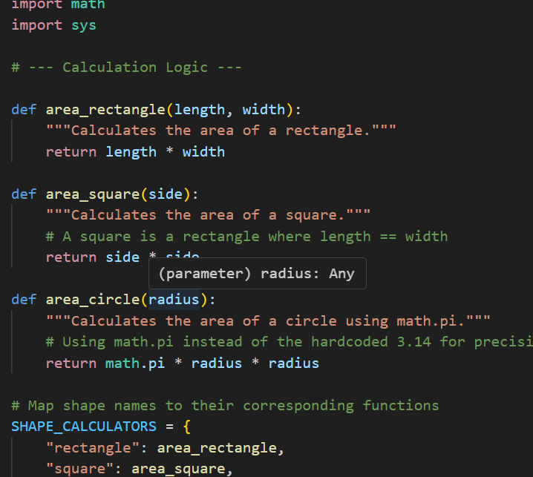  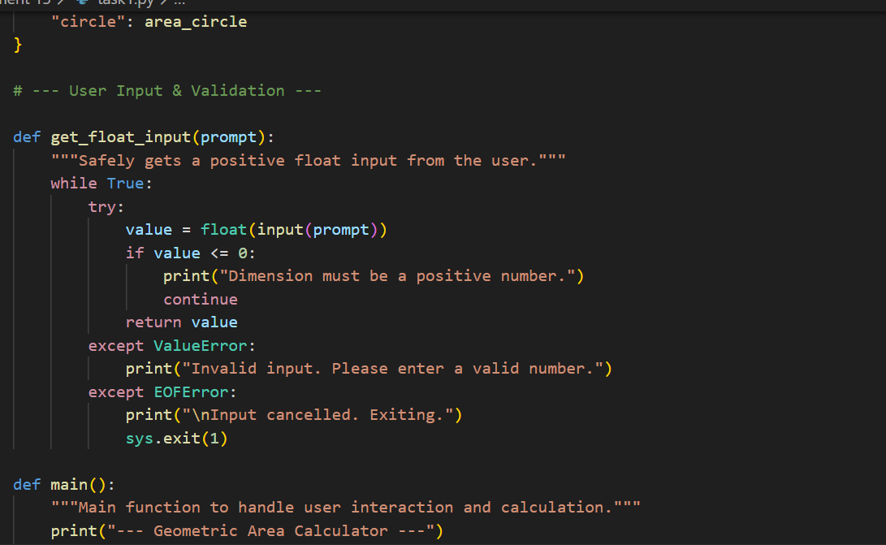  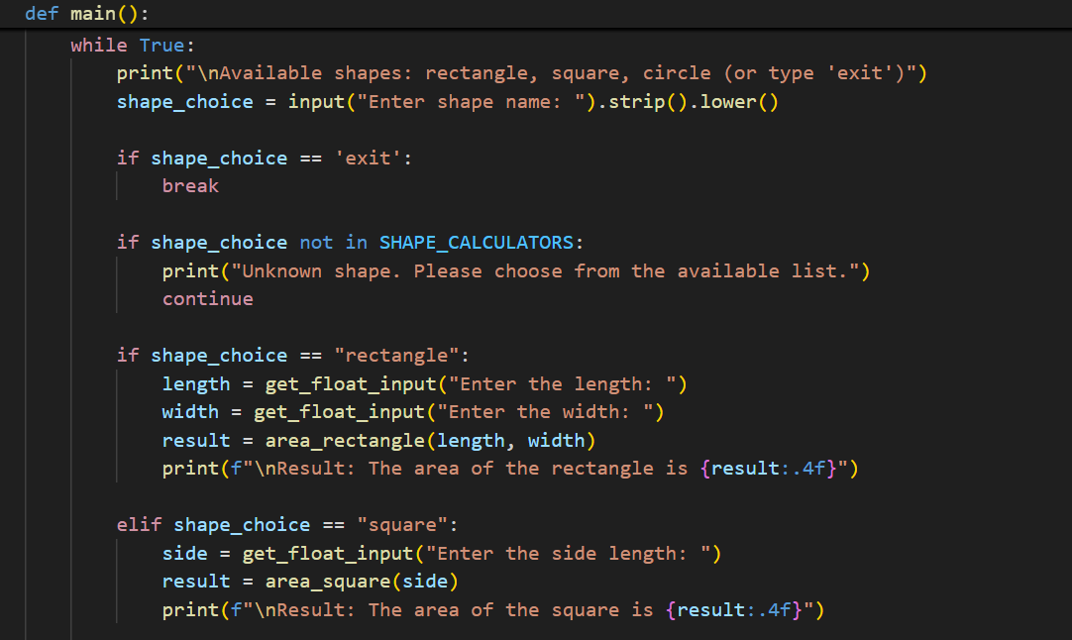  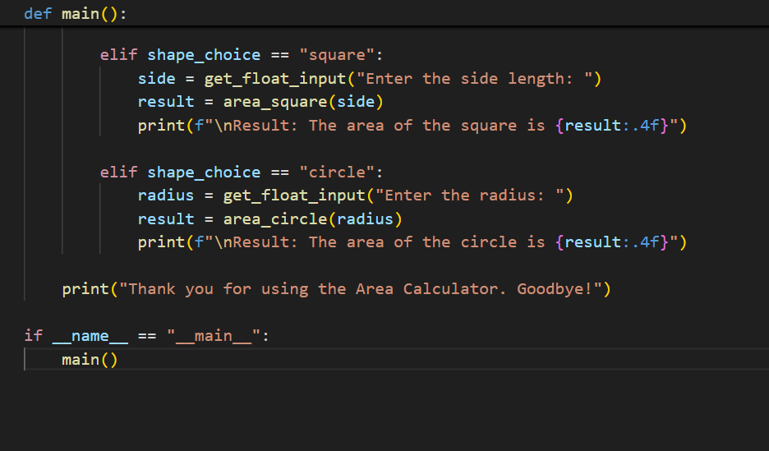  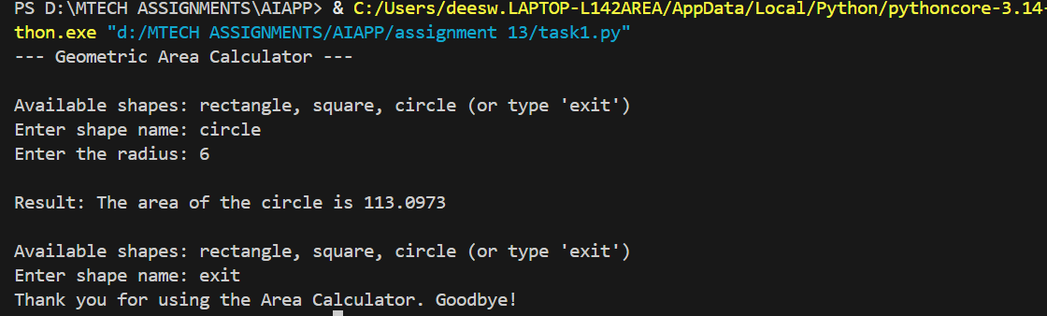  Task Description #2 – Error Handling in Legacy Code  Task: Legacy function without proper error handling  Python Code  def read_file(filename):  f = open(filename, "r")  data = f.read()  f.close()  return data  Expected Output:  AI refactors with with open() and try-except:  Prompt: write a python code for above one and refactor it by giving user inputs.  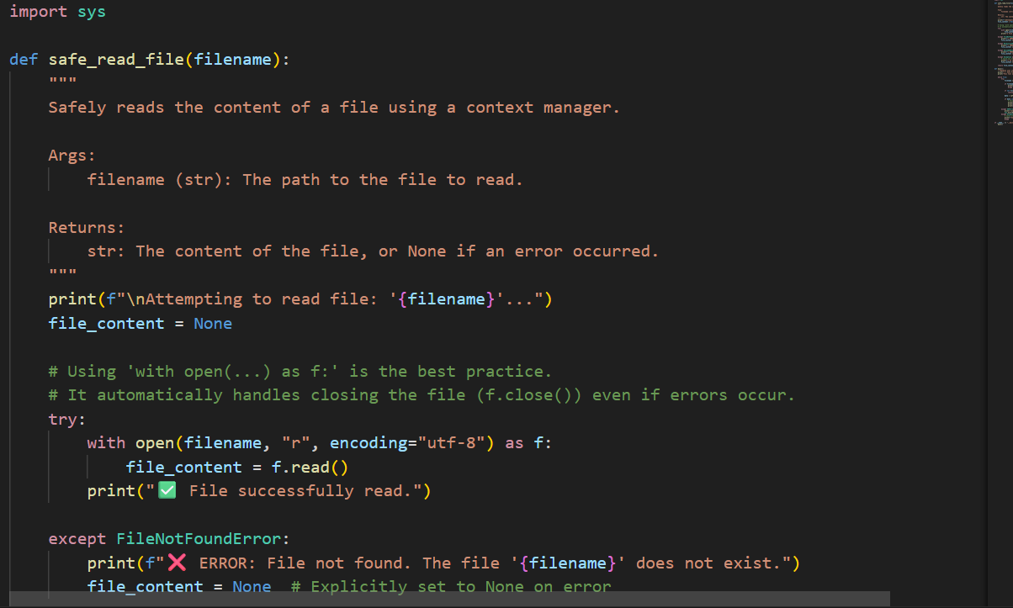  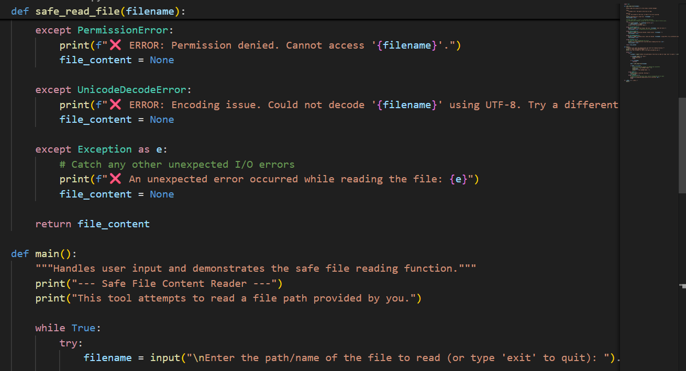  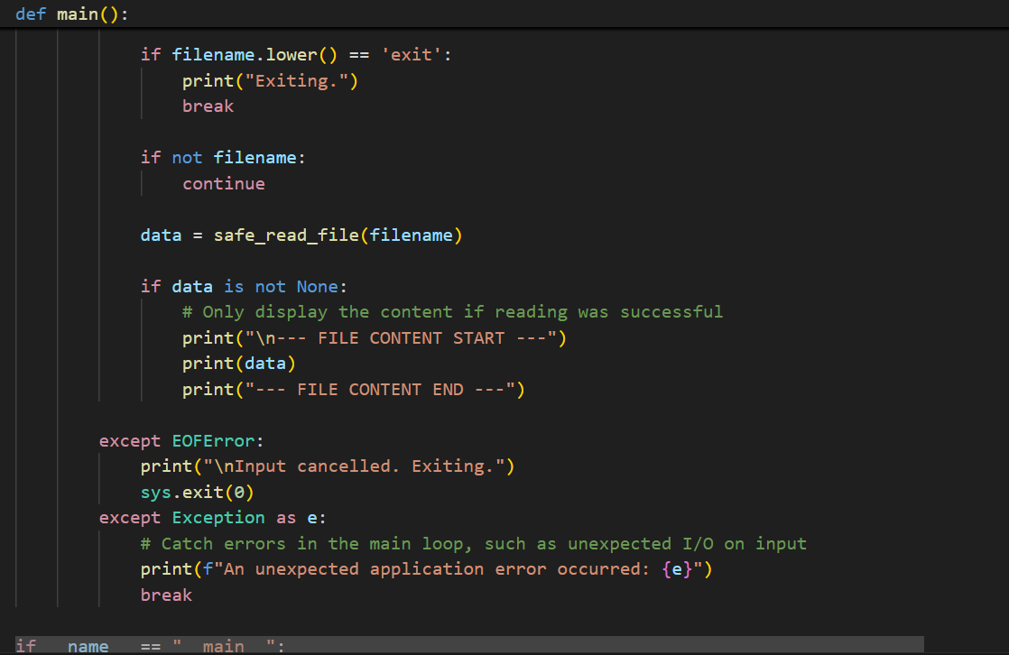  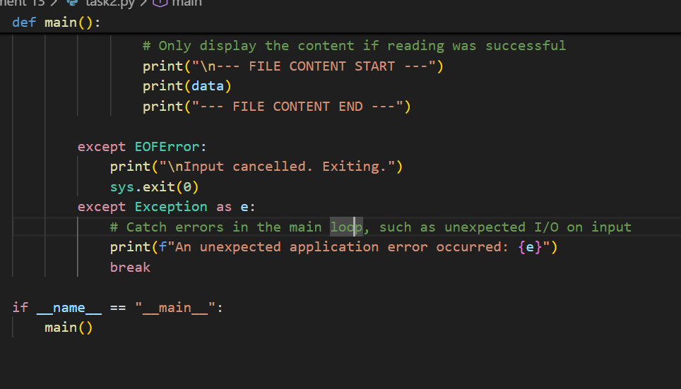  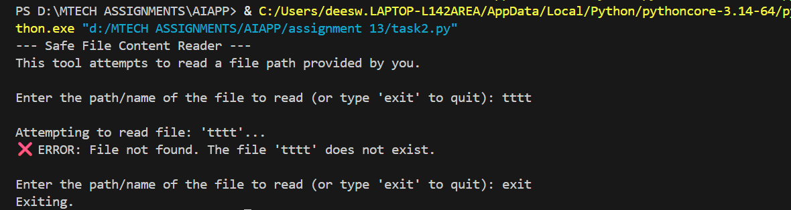  Task Description #3 – Complex Refactoring  Task: Provide this legacy class to AI for readability and modularity improvements:  Python Code  class Student:  def __init__(self, n, a, m1, m2, m3):  self.n = n  self.a = a  self.m1 = m1  self.m2 = m2  self.m3 = m3  def details(self):  print("Name:", self.n, "Age:", self.a)  def total(self):  return self.m1+self.m2+self.m3  Expected Output:  - AI improves naming (name, age, marks).  - Adds docstrings.  - Improves print readability.  - Possibly uses sum(self.marks) if marks stored in a list.  Prompt: write a python code for above one and refactor it by giving user inputs.  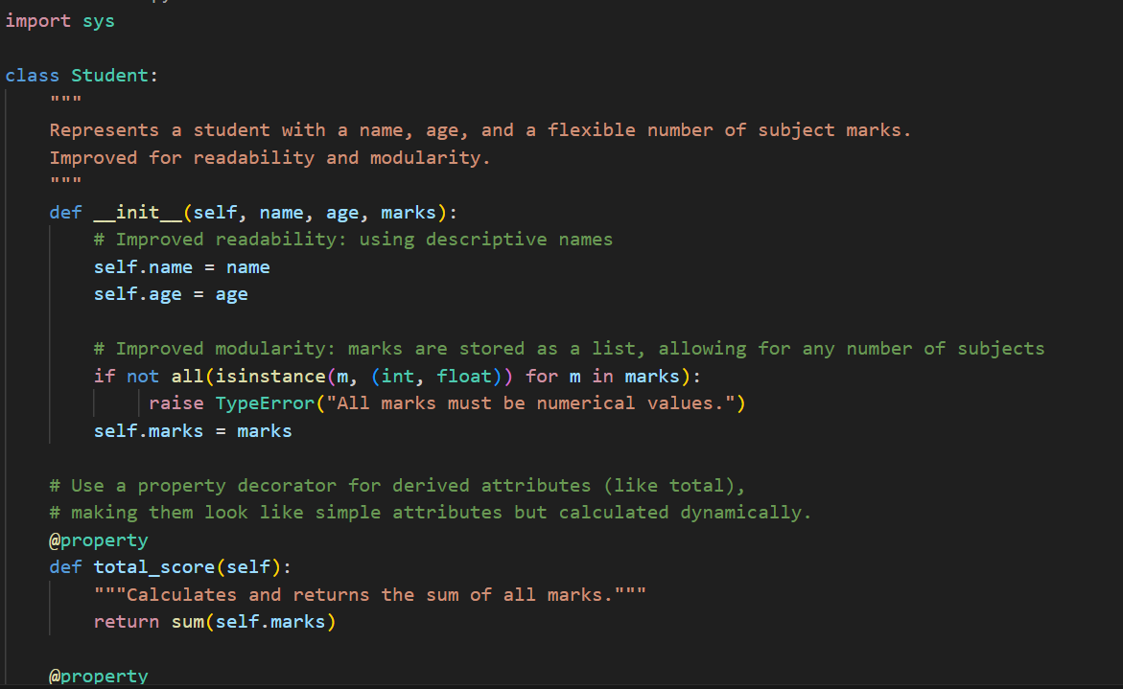  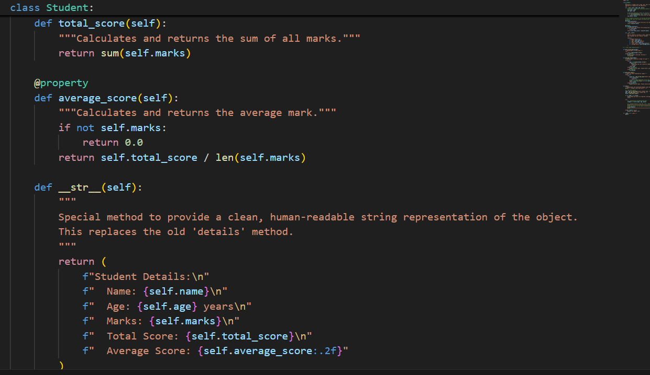  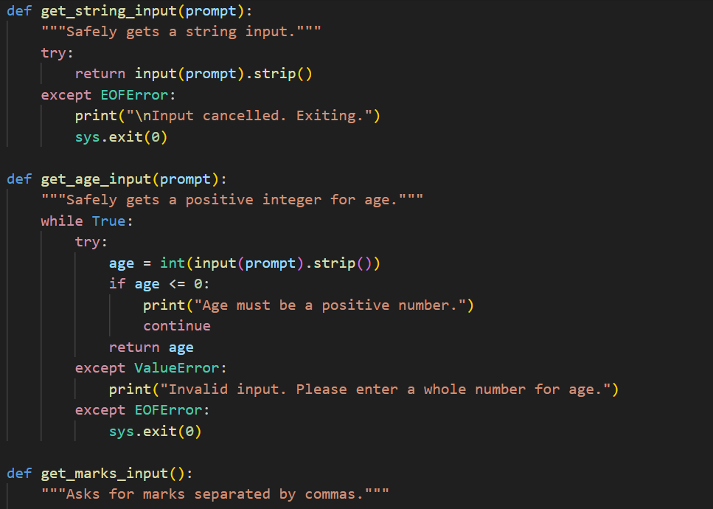  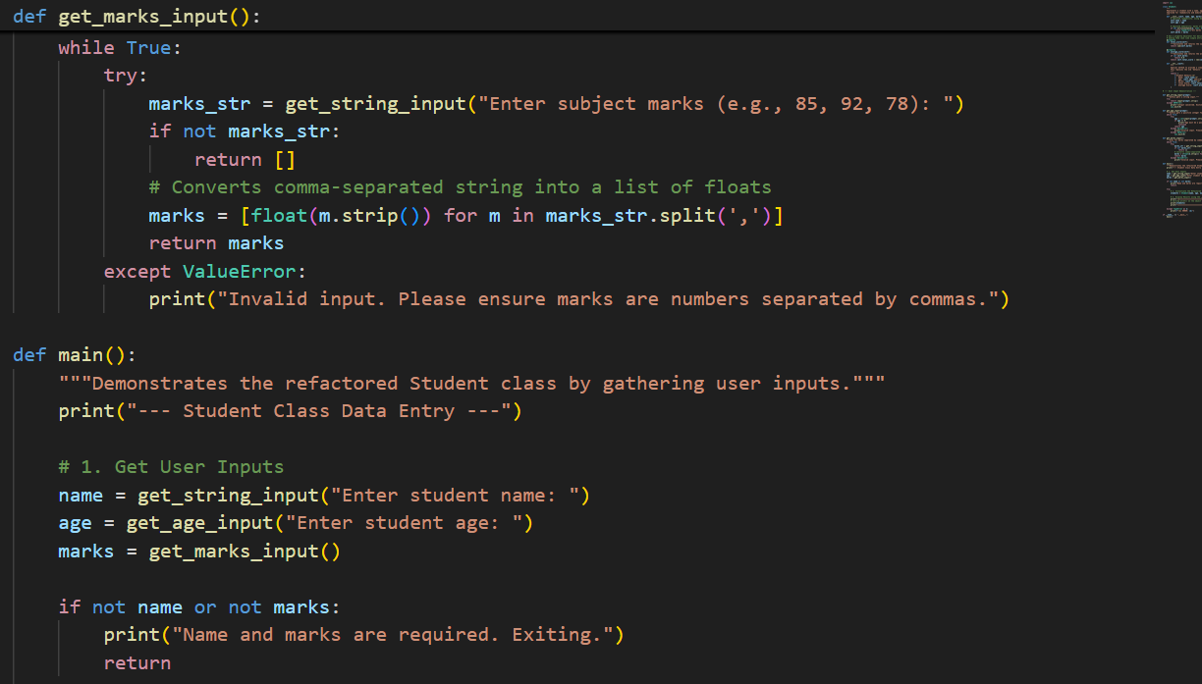  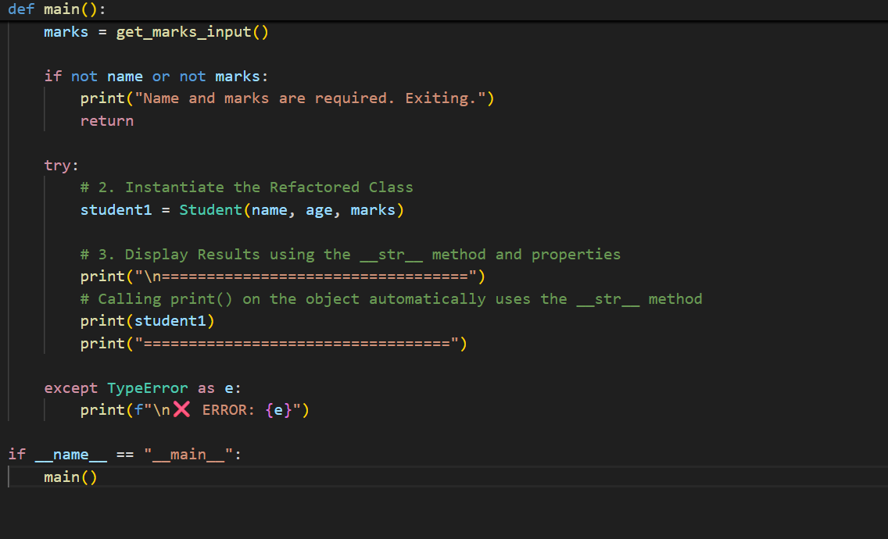  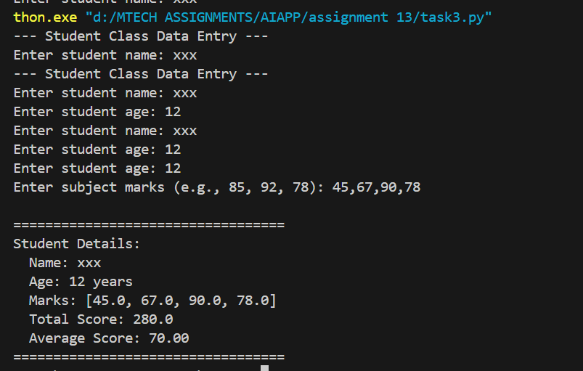  Task Description #4 – Inefficient Loop Refactoring  Task: Refactor this inefficient loop with AI help  Python Code  nums = [1,2,3,4,5,6,7,8,9,10]  squares = []  for i in nums:  squares.append(i * i)  Expected Output: AI suggested a list comprehension  Prompt: : write a python code for above one and refactor it by giving user inputs.  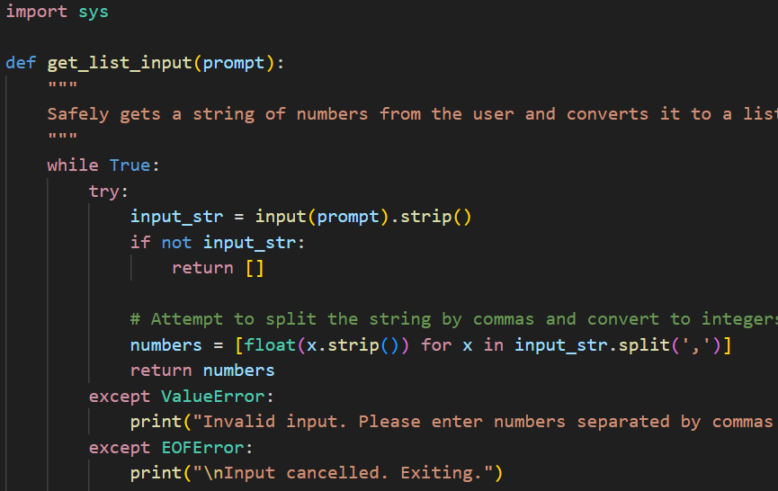  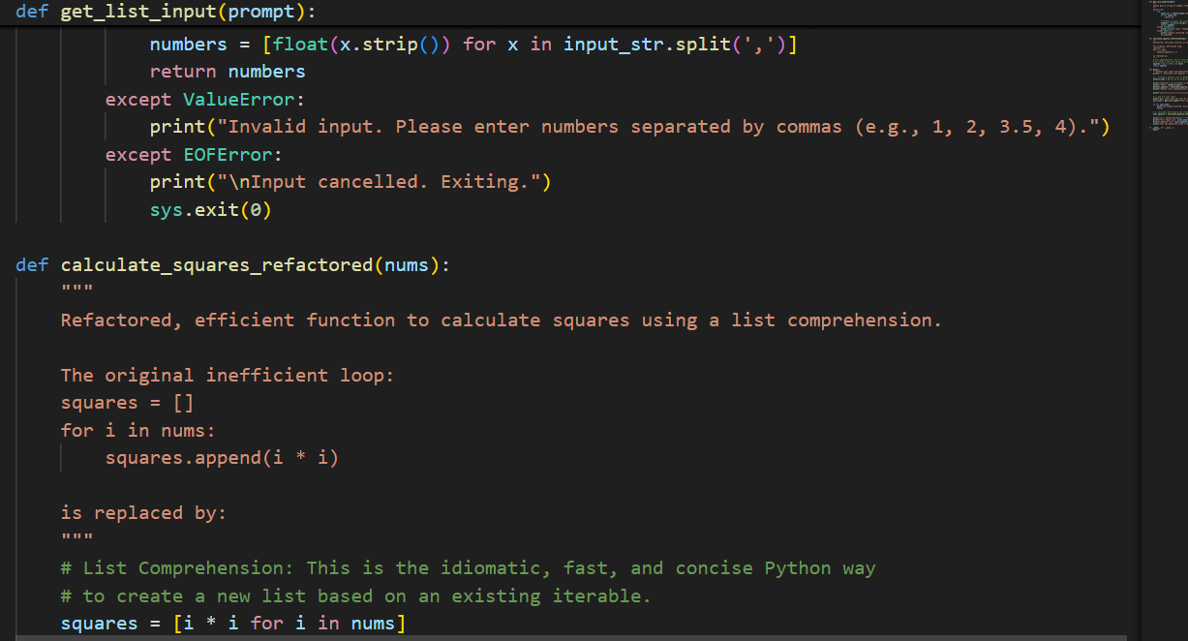  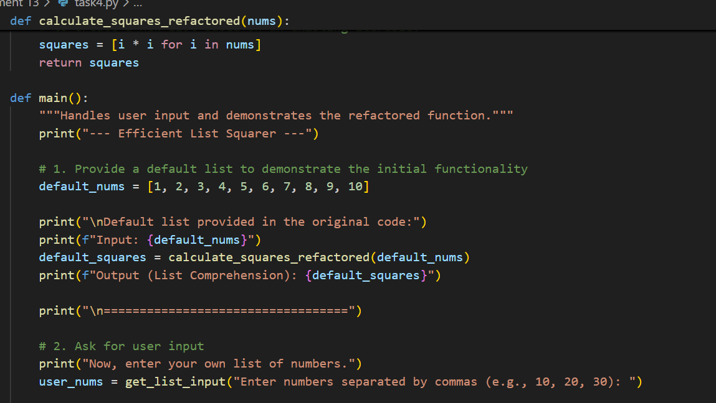  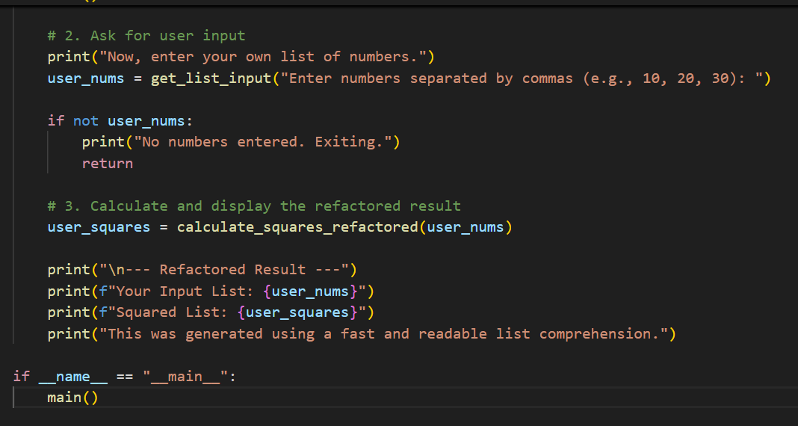  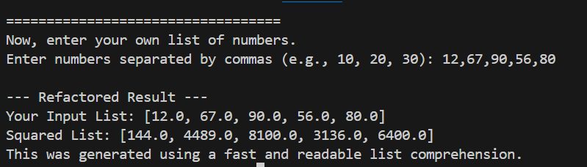 |  |  |  |  |  | Week5- Tuesday

